**Practical -2**

**Text Formatting In HTML**

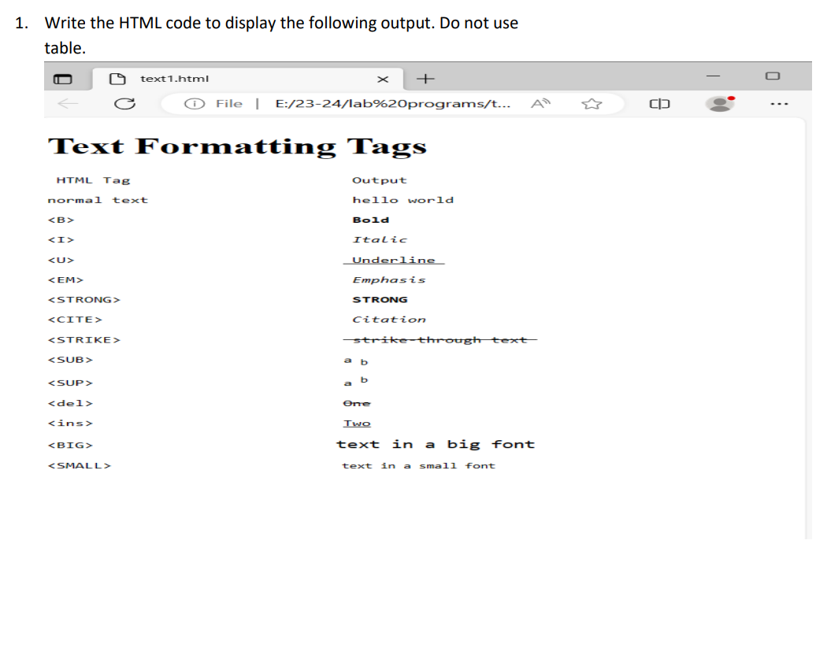

**HTML Code :-**

**<!DOCTYPE html>**

**<html** lang="en"**>**

**<head>**

**<title>**Formatting Tags**</title>**

**</head>**

**<body>**

**<h1>**Text Formating Tags**</h1>**

**<pre>**

**Html Tag**  **Output**

normal text hello world

<code>&lt;B&gt;</code> **<b>**Bold**</b>**

<code>&lt;I&gt;</code> **<i>**Italics**</i>**

<code>&lt;U&gt;</code> **<u>**Underline**</u>**

<code>&lt;EM&gt;</code> **<em>**Emphasis**</em>**

<code>&lt;Strong&gt;</code> **<stong>**Strong**</strong>**

<code>&lt;Cite&gt;</code> **<cite>**Citation**</cite>**

<code>&lt;Strike&gt;</code> **<strike>**Strike Through Text**</strike>**

<code>&lt;Sub&gt;</code> a**<sub>**b**</sub>**

<code>&lt;Sup&gt;</code> a**<sup>**b**</sup>**

<code>&lt;del&gt;</code> **<del>**One**</del>**

<code>&lt;ins&gt;</code> **<ins>**Two**</ins>**

<code>&lt;Big&gt;</code> **<big>**Big**</big>**

<code>&lt;Small&gt;</code> **<small>**Small**</smail>**

**</pre>**

**</body>**

**</html>**

***OUTPUT :-***

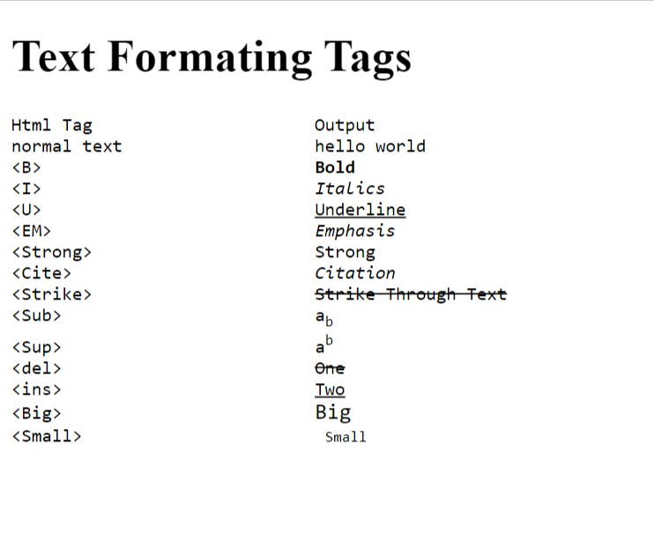

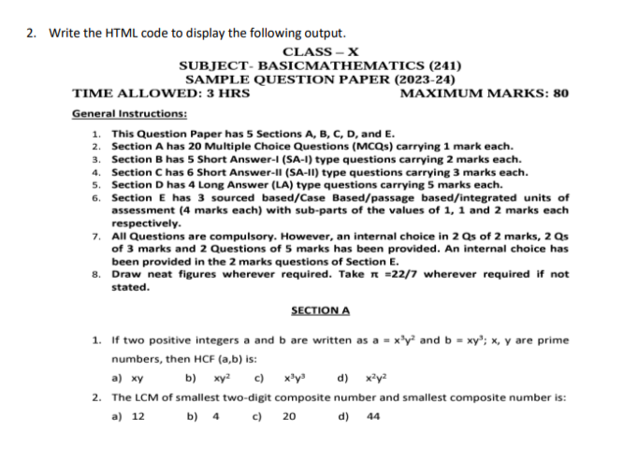

**HTML Code :-**

<!-- Html to print demo question paper -->

<html>

<head>

<title>Demo Question Paper</title>

</head>

<body>

<center>

<h3>Class-X<br>

SUBJECT-BASICMATHEMATICS(241) <br>

SAMPLE QUESTION PAPER(2023-2024)</h3>

</center>

<h3 style="text-align-last : right">MAXIMUM MARKS : 80</h3>

<h3 style="text-align-last : left">TIME ALLOWED : 3 HRS</h3>

<br>

<b><u>General Instructions :</u></b><br>

1. <b>This Question Paper Has 5 Sections A,B,C,D and E.</b><br>

2. <b>Section A has 20 Multiple Choise Questions(MCQ) Carrying 1 Mark Each.</b><br>

3. <b>Section B has 5 short answers-l (SA-1) type questions carying 2 marks each.</b><br>

4. <b>Section C has 6 short answers-ll (SA-ll) type questions carrying 3 marks each.</b><br>

5. <b>Section D has 4 long answers (LA) type questions carrying 5 marks each.</b><br>

6. <b>Section E has 3 sourced based/case based/ passed based/integrated units of assessment (4 marks each) with sub-parts of the values of 1,1 and 2 marks each respectively.</b><br>

7. <b>All questions are compulsory. However, an internal choise in 2 Qs of 2 marks, 2 Qs of 3 marks and 2 questions of 5 marks has been provided. An internal choise has been provided in the 2 marks question of Section E.</b><br>

8. <b>Draw neat figures wherever required. Take &pi;=22/7 wherever required if not stated.</b><br>

<center>

<h4><u>SECTION A</u></h4>

</center>

<p>

1. If two positive integers a and b are written as a= x<sup>3</sup>y<sup>2</sup> and b=xy<sup>3</sup>; x,y are prime numbers, then HCF(a,b) is :

<pre>

a) xy b)xy<sup>2</sup> c)x<sup>3</sup>y<sup>3</sup> d)x<sup>2</sup>y<sup>2</sup>

</pre>

</p>

<p>

2. The LCM of smallest two-digit composite number and smallest composite number is:

<pre>

a) 12 b) 4 c) 20 d) 44

</pre>

</p>

</body>

</html>

***OUTPUT : -***

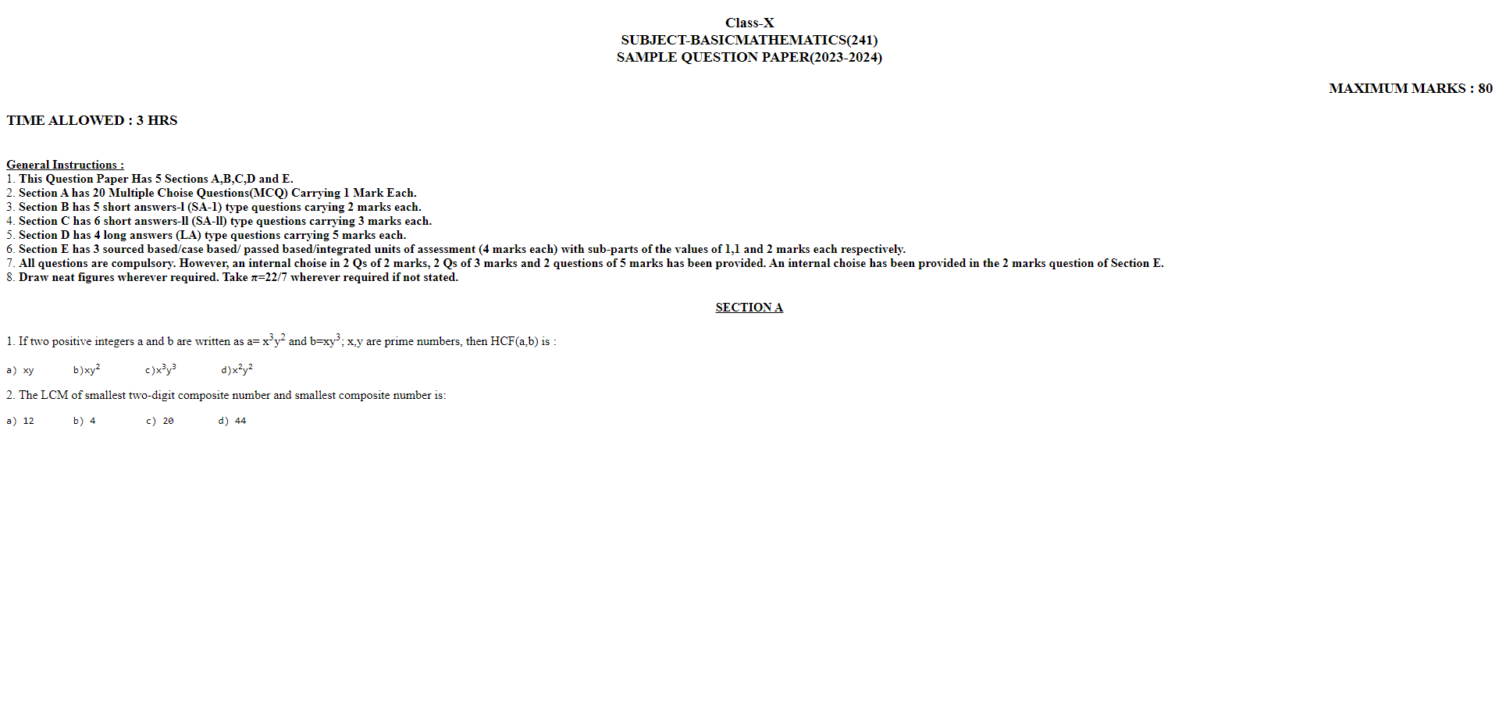

3. Write the HTML code to display your Resume.

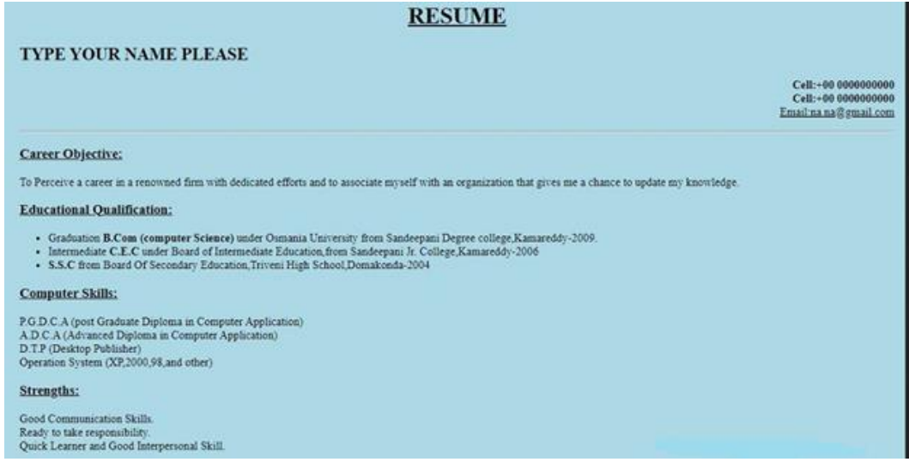

**HTML code : -**

<!-- Print resume -->

<!DOCTYPE html>

<html lang="en">

<head>

<title>Resume</title>

</head>

<body bgcolor="lightblue">

<center>

<h1><u>RESUME</u></h1>

</center>

<h2>NIKHIL LATHIYA</h2>

<p style="text-align: right">

Cell: +91 0000000000 <br>

Email: abc@gmail.com

</p>

<hr>

<h3>

<u>Career Objective :</u>

</h3>

<p>To percive a career in a renowed firm with dedicated efforts and to associate myself with an organization that gives me a chance to update my knowledge.</p>

<h3><u>Educational Qualifications</u></h3>

<p>

&bullet;Graduation <b>BCA (Computer Science)</b>under Kachchh University from DNV College, Gandhidham. <br>

&bullet;Intermediate <b>C.E.C</b> under Board of Intermediate Education from DNV college, Gandhidham. <br>

&bullet;<b>S.S.C</b> from GSEB, Modern School, Gandhidham.

</p>

<h3>

<u>Computer Skills:</u>

</h3>

<p>

P.G.D.C.A (Post graduate in computer applications)<br>

A.D.C.A (Advanced diploma in computer applications)<br>

D.T.P (Desktop Publisher)<br>

Operating System (Xp, 2000, 98 and other)

</p>

<h3>

<u>Strengths</u>

</h3>

<p>

Goodto communicate.<br>

Ready to take responsibility.<br>

Quick learner and good interpersonal skill.<br>

</p>

</body>

</html>

***OUTPUT*** :-

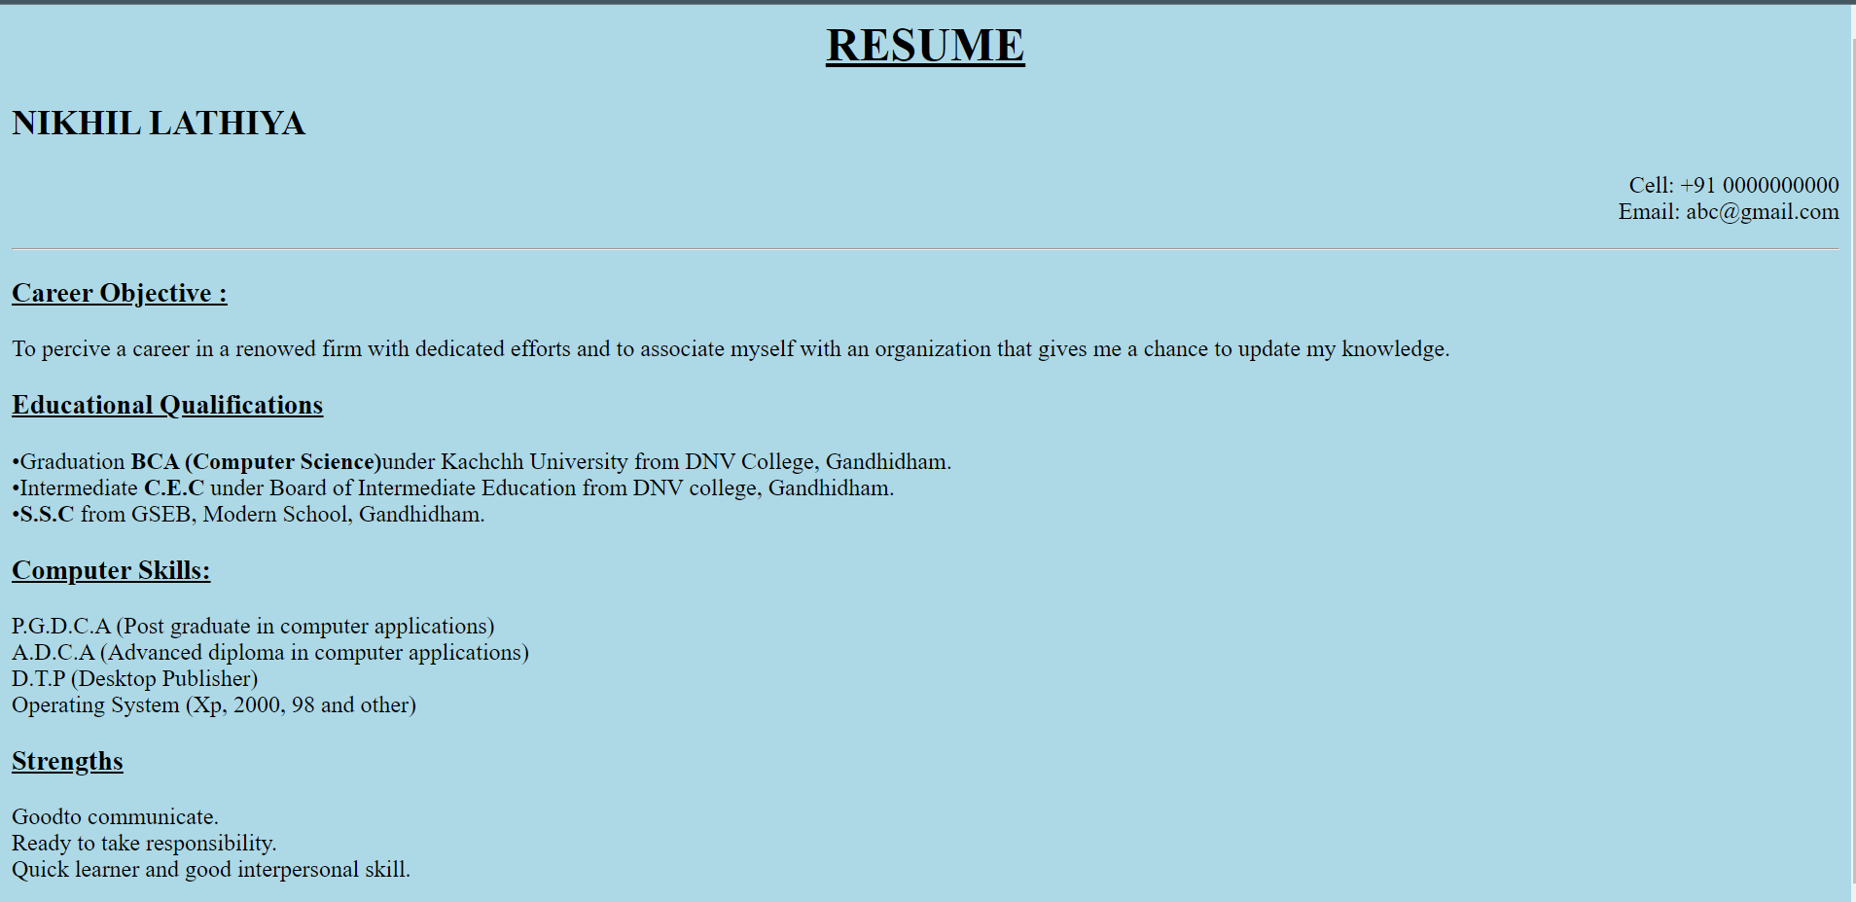

4. Print the squares of the numbers 1 - 20. Each number should be on a separate line, next to it the number 2 superscripted, an equal sign and the result. (Example: 102 = 100)

***HTML code :-***

<!-- Print squares from 1 to 20 -->

<!DOCTYPE html>

<html lang="en">

<head>

<meta charset="UTF-8">

<meta name="viewport" content="width=device-width, initial-scale=1.0">

<title>Print Squares</title>

</head>

<body>

<h1>Print Squares From 1 to 20</h1>

<p>

1<sup>2</sup> = 1.<br>

2<sup>2</sup> = 4.<br>

3<sup>2</sup> = 9.<br>

4<sup>2</sup> = 16.<br>

5<sup>2</sup> = 25.<br>

6<sup>2</sup> = 36.<br>

7<sup>2</sup> = 49.<br>

8<sup>2</sup> = 64.<br>

9<sup>2</sup> = 81.<br>

10<sup>2</sup> = 100.<br>

11<sup>2</sup> = 121.<br>

12<sup>2</sup> = 144.<br>

13<sup>2</sup> = 169.<br>

14<sup>2</sup> = 196.<br>

15<sup>2</sup> = 225.<br>

16<sup>2</sup> = 256.<br>

17<sup>2</sup> = 289.<br>

18<sup>2</sup> = 324.<br>

19<sup>2</sup> = 361.<br>

20<sup>2</sup> = 400.<br>

</p>

</body>

</html>

***OUTPUT :-***

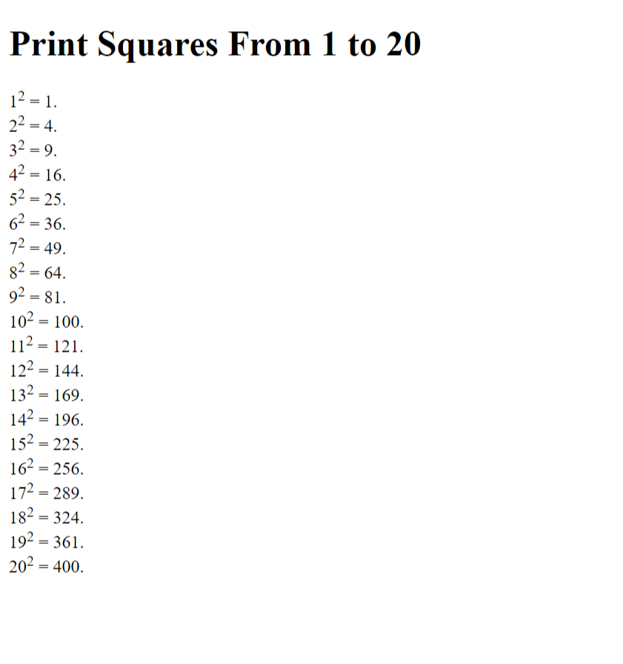

5. Write a HTML code to overriding text direction. (hint using bdo element with )

***HTML code :-***

<!-- Html code to overriding text direction -->

<!DOCTYPE html>

<html lang="en">

<head>

<meta charset="UTF-8">

<meta name="viewport" content="width=device-width, initial-scale=1.0">

<title>Overriding text direction</title>

</head>

<body>

<p>

<bdo dir="ltr">Text Will Go Left To Right.</bdo>

</p>

<p>

<bdo dir="rtl">Text Will Go Right To Left.</bdo>

</p>

</body>

</html>

***OUTPUT :-***

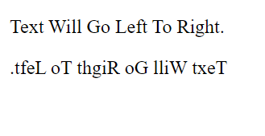

6. Write a HTML code to implement long and short quotation. (hint use <Q> and <blockquote>)

***HTML code :-***

<!-- HTML code to implement long and short quotations -->

<!DOCTYPE html>

<html lang="en">

<head>

<title>Quotations</title>

</head>

<body>

<p>Blockquote</p>

<blockquote cite="BLOCKQUOTE">It is used to implement long quotations in html.</blockquote>

<p>Q tag :- <q>This Is Quotes</q></p>

</body>

</html>

***OUTPUT :-***

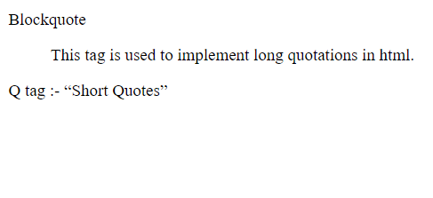

7. Write a HTML code to implement div and span tags. (hint use <div>and <span> tag)

***HTML Code :-***

<!-- Implementation of Div and Span Tag -->

<!DOCTYPE html>

<html lang="en">

<head>

<title>Div and span</title>

</head>

<body>

<div style="background-color: orange">This is a div tag 1</div>

<span style="background-color: brown">

This is span tag 1.

</span>

</body>

</html>

***OUTPUT*** :-

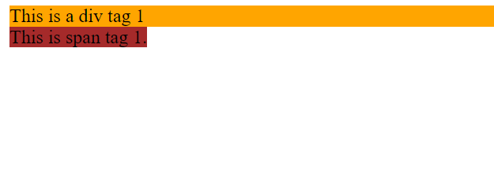

8. Write a HTML code to display the following output. (hint use <code>)

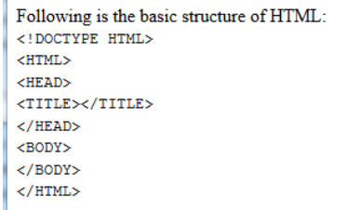

***HTML Code:-***

<!-- Implementation of code tag -->

<!DOCTYPE html>

<html lang="en">

<head>

<title>Code Tag</title>

</head>

<body>

<h4>Following is the basic structure of HTML :</h4>

<code>

&lt;!DOCTYPE HTML&gt;<br>

&lt;HTML&gt;<br>

&lt;HEAD&gt;<br>

&lt;TITLE&gt;&lt;/TITLE&gt;<br>

&lt;/HEAD&gt;

&lt;BODY&gt;<br>

&lt;/BODY&gt;<br>

&lt;/HTML&gt;<br>

</code>

</body>

</html>

***OUTPUT :-***

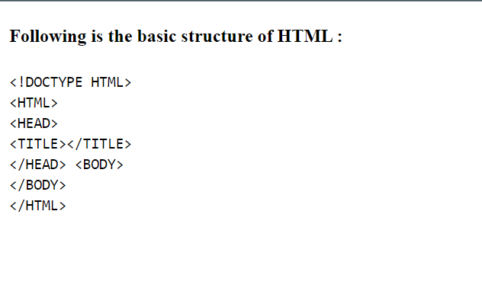

9. Create an HTML web page to implement various character entities in HTML. Implement at least 10 character entities (refer <https://tools.w3cub.com/html-entities>)

***HTML Code :-***

<!-- Character Entities -->

<!DOCTYPE html>

<html lang="en">

<head>

<meta charset="UTF-8">

<meta name="viewport" content="width=device-width, initial-scale=1.0">

<title>Character E#ntities</title>

</head>

<body>

<h1>HTML character entities</h1>

&lt; <br>

&gt; <br>

&pi; <br>

&bullet; <br>

&dash; <br>

&ndash; <br>

&prime; <br>

&caret; <br>

&ocy; <br>

&chcy; <br>

</body>

</html>

***OUTPUT :-***

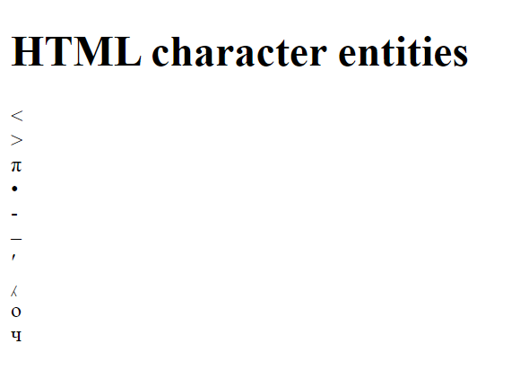

10. How to insert a copyright symbol on a browser page?

***HTML Code :-***

<!-- Insert Copyright -->

<!DOCTYPE html>

<html lang="en">

<head>

<meta charset="UTF-8">

<meta name="viewport" content="width=device-width, initial-scale=1.0">

<title>Insert Copyright</title>

</head>

<body>

&copy; Copyright symbol.

</body>

</html>

***OUTPUT*** :-

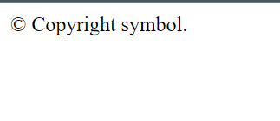

-----------------------------XXXXXXXXXX-----------------------------------